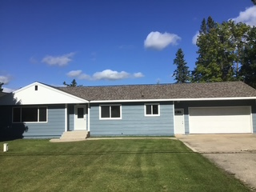
HC745: 3 bedroom home $219,000
9456 OO.25 Rd, GARDEN, MI 49835
1 Story Ranch over a Crawl with Attached garage
Great location between Escanaba (30 minutes) and Manistique (15 minutes) great for commuting between work or college in either town.. Located near a nice day park and a great swimming beach.
2 miles from Big Bay de Noc School
3 Bedroom Home (1348 sq ft) with  1 Full Bath  Home Build 1963 added Garage 1964  Garage - 528 sq ft (22x24)  12x12 shed / Need repairing  100'on x 200' located on M183 (survey available)  Roof is less than a year old. | Upgrades:  2012 New windows  2016 New Septic system (2 tanks with raised field) (DesJarden Excavation)  2024-2025 New Shingled roof, fascia and  soffits  Siding and paint  Totally Remodeled full Bath  Fresh paint throughout  Ist Floor Laundry  New carpet and Vinyl Plank Flooring  All New Trim and interior doors  New Sump Pump  New Submersible in drilled well  Three New Exterior Doors except small entrance back garage door  New Light fixtures

